## **Checkout issue #1: Sign-in**



**Situation:**

A significant number of customers for Tee’s Shirts are abandoning the checkout process when they reach the sign-in page. The page asks the customer to sign in or create an account.

Here is how the store’s sign-in page appears during checkout:

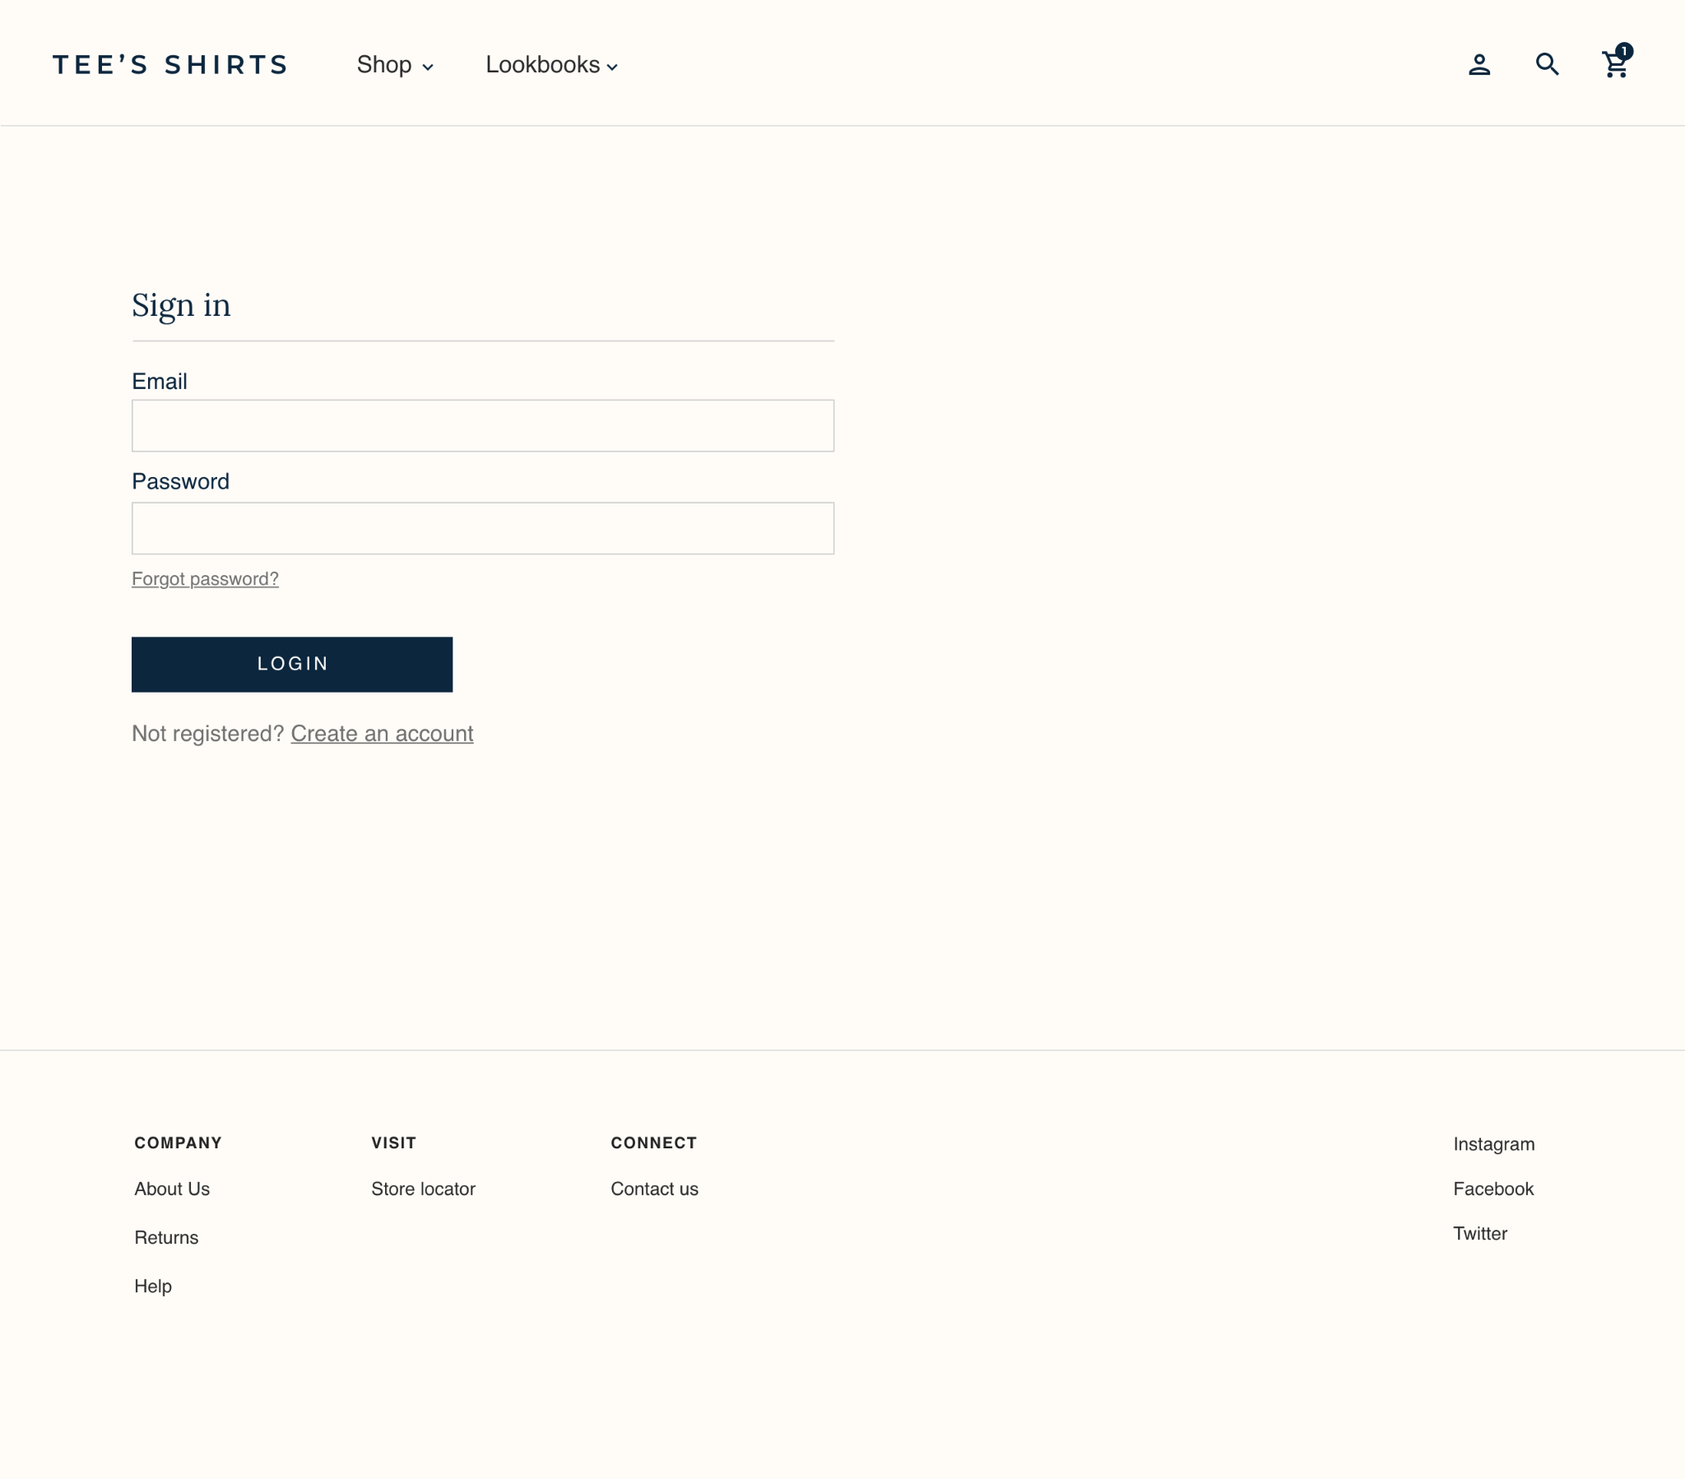

| **Step 1: Identify the issue. Why might customers abandon the checkout process at this point?** |
| --- |
| The customer doesn’t want to sign in into an account just to purchase. |

| **Step 2: Suggest improvements. Identify one or two ways to address this issue and improve the checkout process.** |
| --- |
| Add a guest check out where the customer doesn’t need to purchase products using an account. |

## 

## **Checkout issue #2: Personal information**



**Situation:**

Customers for Tee’s Shirts are also abandoning the checkout process when asked to provide their personal information. The checkout process requires them to enter the following details:

* Name
* Address
* Email address
* Home phone number
* Work phone number
* Mobile phone number
* Birthdate

Here is how the personal information fields appear during checkout:

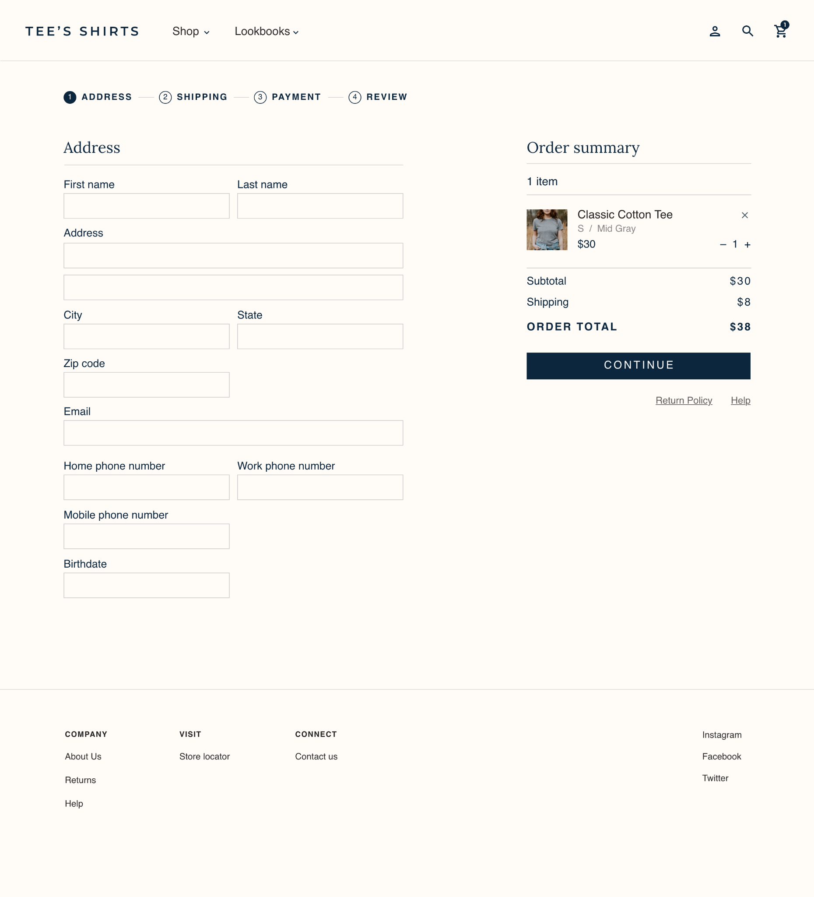

| **Step 1: Identify the issue. Why might customers abandon the checkout process at this point?** |
| --- |
| Too much information is needed just to make a purchase. |

| **Step 2: Suggest improvements. Identify one or two ways to address this issue and improve the checkout process.** |
| --- |
| Simplify the checkout process by omitting information not needed. In this situation, a birthdate isn’t needed. For the phone fields condense it into one field and just say phone number. |

## 

## **Checkout issue #3: Shipping**



**Situation:**

Customers for Tee’s Shirts are also abandoning the checkout process when asked to choose a shipping option. The shipping options include the following:

* Standard shipping starting at $8
* Express shipping starting at $15

Here is how the store’s shipping options appear during checkout:

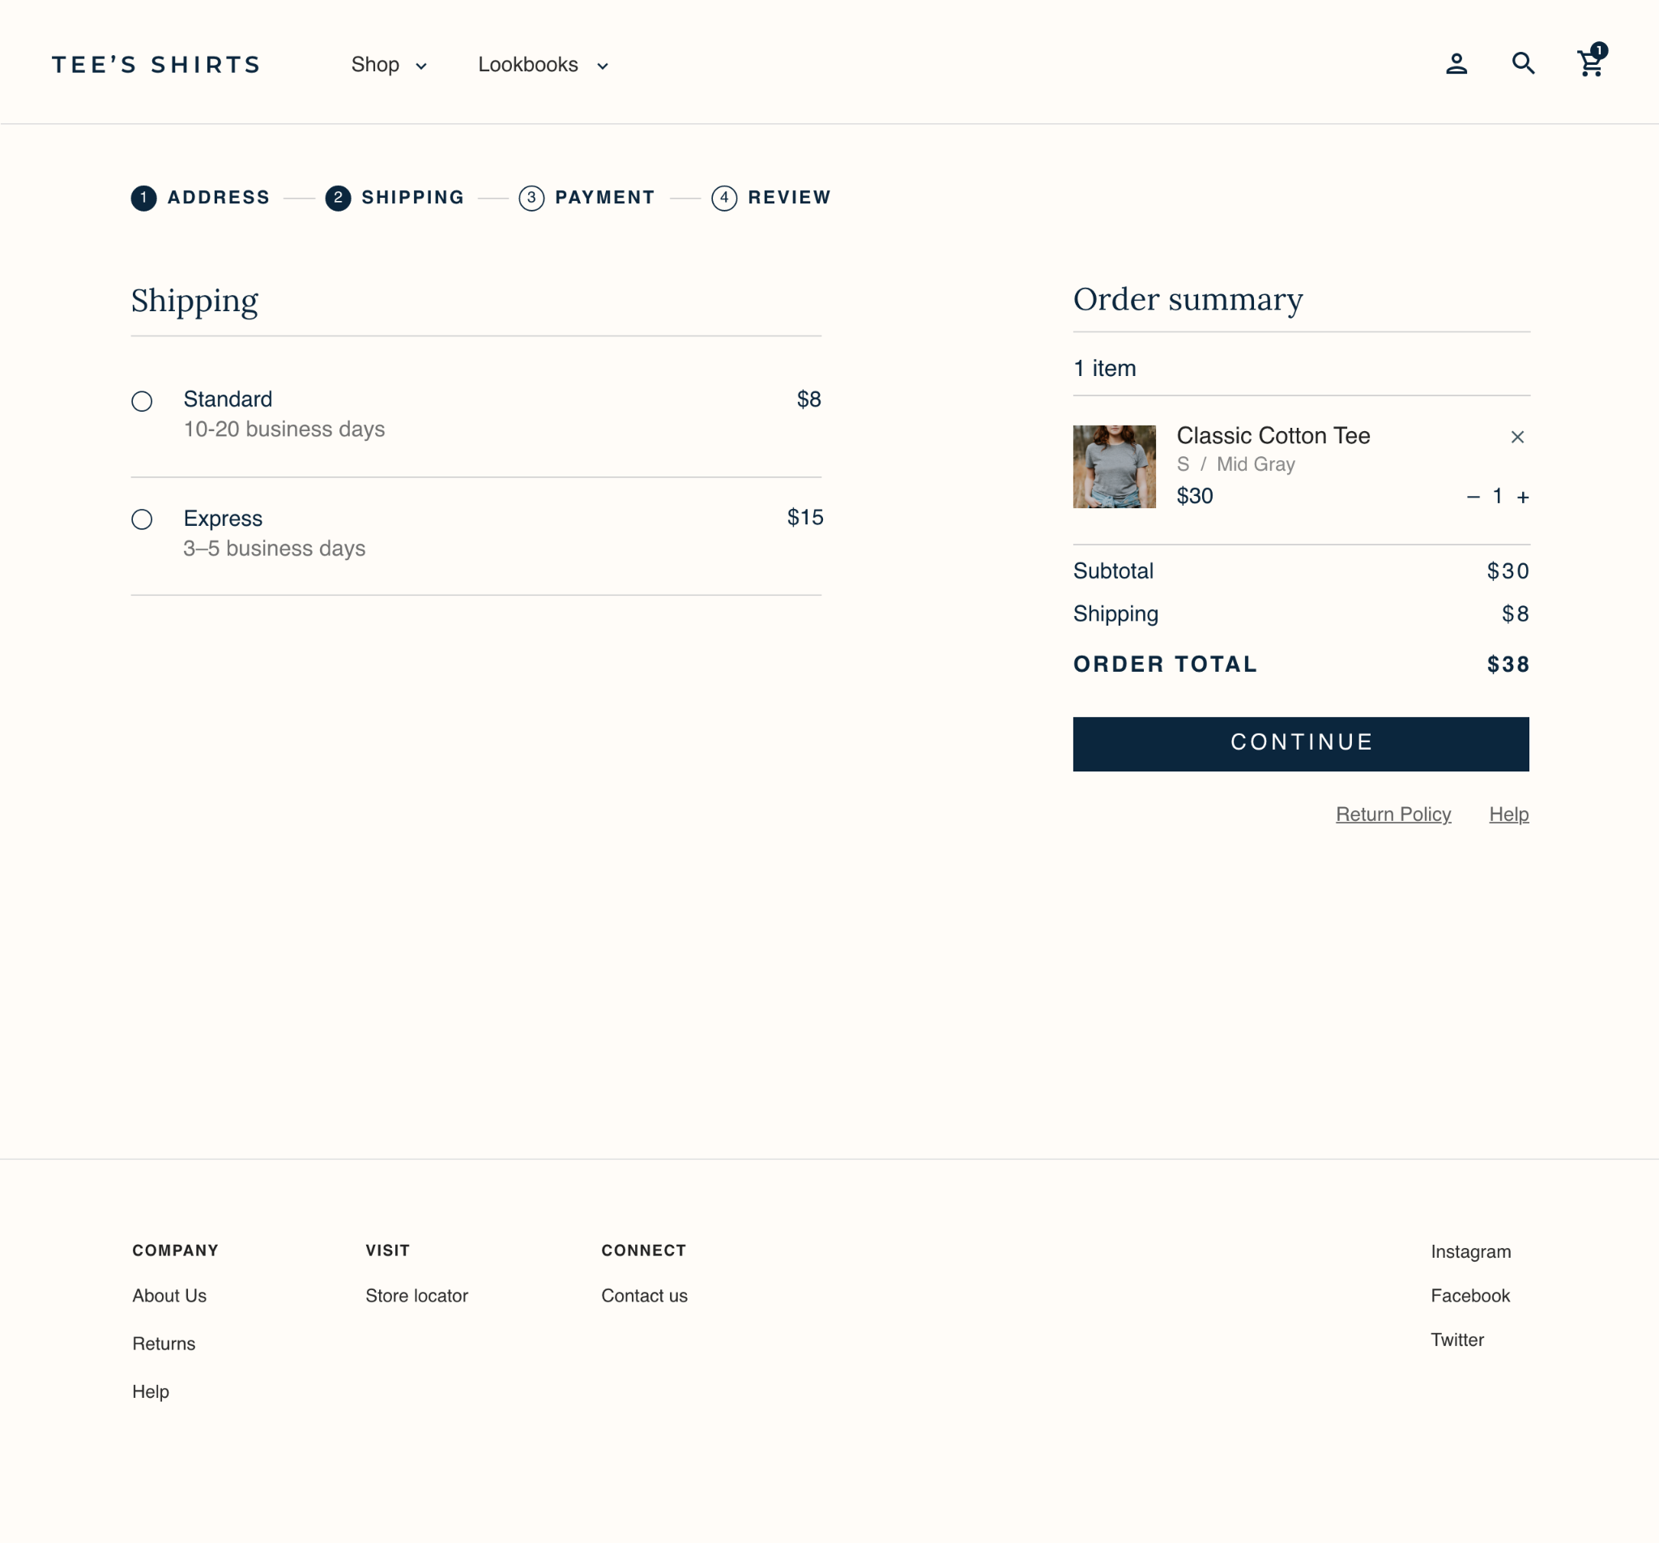

| **Step 1: Identify the issue. Why might customers abandon the checkout process at this point?** |
| --- |
| The extra fee is too high for customers so they abandon their cart. |

| **Step 2: Suggest improvements. Identify one or two ways to address this issue and improve the checkout process.** |
| --- |
| Provide a free shipping option. You can have a free shipping option if their total is above a certain purchase. |

## 

## **Checkout issue #4: Payment**



**Situation:**

Customers for Tee’s Shirts are also abandoning the checkout process when asked to enter their payment information. The online store accepts credit cards.

Here is how the store’s payment options appear during checkout:

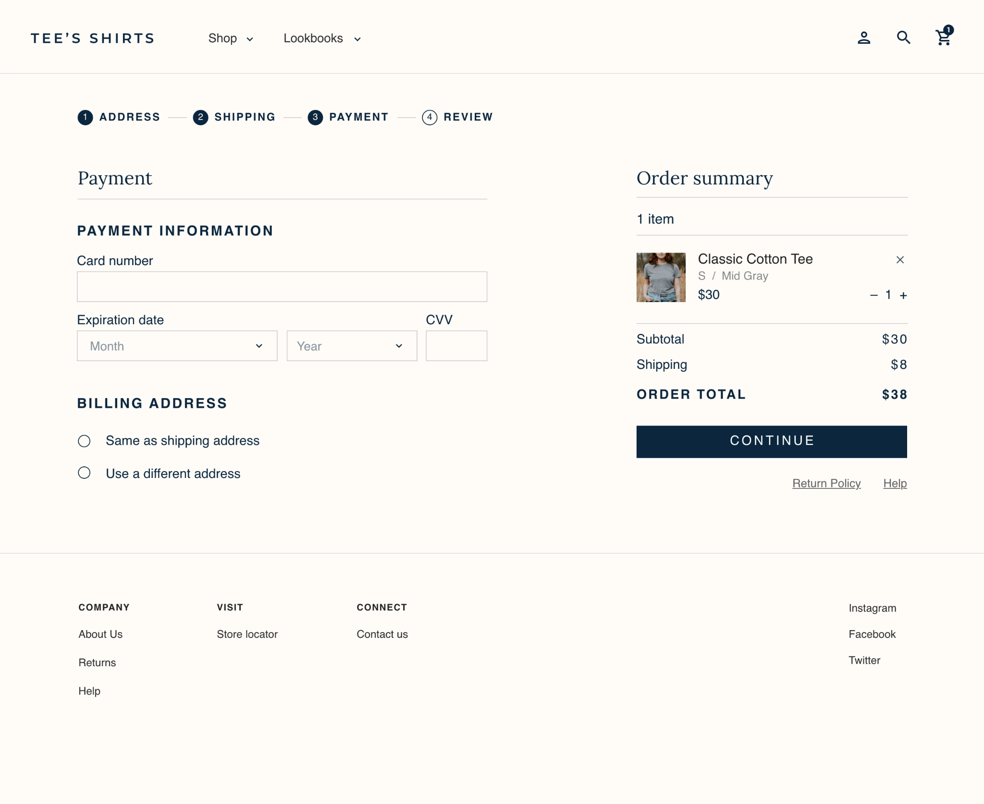

| **Step 1: Identify the issue. Why might customers abandon the checkout process at this point?** |
| --- |
| Customers don't want to use credit cards as payment and they abandon the cart. They also feel a lack of security. |

| **Step 2: Suggest improvements. Identify one or two ways to address this issue and improve the checkout process.** |
| --- |
| Add more payment methods that they can use like google pay and paypal. Also highlight return policy and security certificate as an info to build confidence that the payment process is secure. |

## 